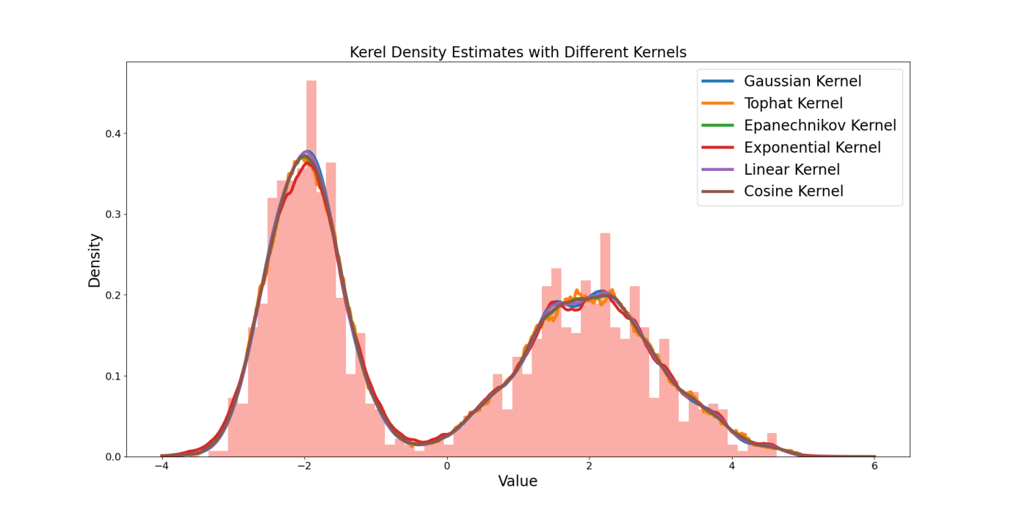

**Figure 1.**Density curves calculated with different kernel functions

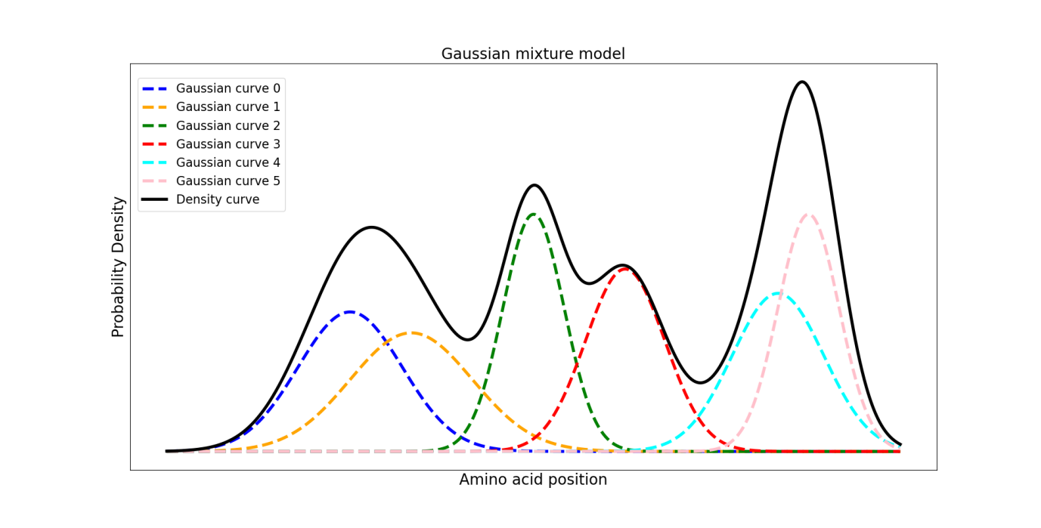

**Figure 2.**Gaussian Mixture Model

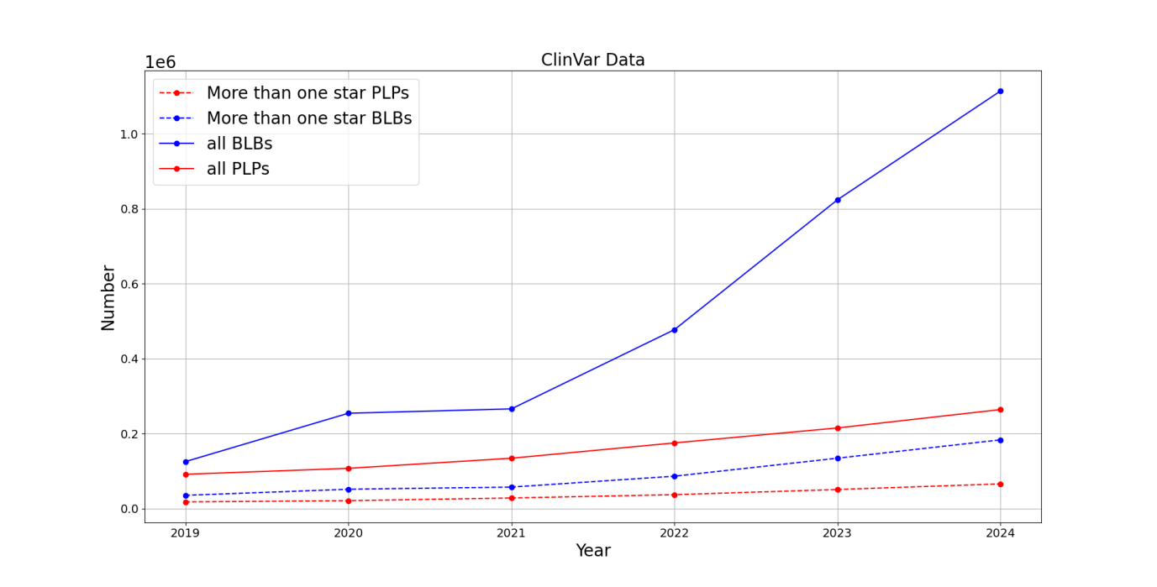**Figure 3.**Distribution of various types of mutations reported in the Clinvar database from 2019 to 2024

**Bandwidth Calculation Steps.**

Obtaining the optimal fixed bandwidth for a specific amino acid sequence by minimizing the *Mean Integrated Squared Error (MISE)*:

$$MISE(h)=E\int{{(f^{∗}(x)−f(x))}^{2}dx}$$

And $MISE(h)=AMISE(h)+o(\frac{1}{nh}+h^{4})$*,*where *AMISE* stands for the Asymptotic Mean Integrated Squared Error. *AMISE* has:

$$AMISE(h)=\frac{R(K)}{nh}+\frac{1}{4}m_{2}{(K)}^{2}h^{4}R(f^{''})$$

Where:

$$R(K)=\int{K{(x)}^{2}dx,m_{2}(x)=\int{x^{2}K(x)dx}}$$

Minimizing *MISE(h)* is equivalent to minimizing *AMISE(h)*. Taking the derivative and setting it to zero gives:

$$\frac{∂}{∂h}AMISE(h)=−\frac{R(K)}{nh^{2}}+m_{2}(K)^{2}h^{3}R(f^{"})=0$$

Yield:

$$h_{AMISE}=\frac{R(K)^{\frac{1}{5}}}{m_{2}(K)^{\frac{2}{5}}R(f^{''})^{\frac{1}{5}}n^{\frac{1}{5}}}$$

Once the kernel function is determined, the values of *R, m* and $f^{''}$ in the formula for *h* can be established, and *h* will have an analytical solution. We have chosen the Gaussian kernel function, so the optimal bandwidth we select is:

$$h=(\frac{4σ^{5}}{3n})^{\frac{1}{5}}=1.059σn^{−\frac{1}{5}}$$

Where σ is the standard deviation of the sample.

**Expectation Maximization Algorithm**

The EM algorithm consists of three steps: the E-step (calculating the expected values of *μ* and *σ*), the M-step (computing the maximum likelihood estimates of these two parameters from the E-step for the Gaussian model), and the iteration step (repeating the E-step and M-step until these parameters converge). This process determines the boundaries of mutation clusters, through which a set of mutation clusters can be identified.

Specific steps:

1. Initialize *μ* and *σ*. We set the maximum values of the kernel density curve to be $\max_{k}$*(k=1,2,...,K)*, where *K* is the number of maximum values. Each maximum value corresponds to two minimum values on either side, $\min_{k} and \min_{k+1}$, and in the edge case where there are no local minimum values before or after *k*, the values *(0,f(0))* and *(L,f(L))* are used as local minimum values depending on the situation. where *L* is the length of the amino acids in the gene. Then the initial parameters $μ_{k}$ and $σ_{k}$ for each Gaussian distribution are given by the following formula:
$$μ_{k}=\max_{k}，σ_{k}=\frac{\min_{k+1}−\min_{k}}{2}$$

2. Calculate the probabilities of all samples belonging to each category:
$$γ_{i,k}=\frac{w_{k}N(x_{i}|μ_{k},σ_{k})}{\sum_{s=1}^{k}{w_{s}N(x_{i}|μ_{s},σ_{s})}}(i=1,2,3,...,n,k=1,2,3,...,K)$$

3. Update $u_{k} and σ_{k}$

$$μ_{k}=\frac{\sum_{i=1}^{n}{γ_{i,k}X_{i}}}{\sum_{i=1}^{n}{γ_{i,k}}}，$$

$$σ_{k}=\frac{\sum_{i=1}^{n}{γ_{i,k}{(X}_{i}−u_{k})^{T}{(X}_{i}−u_{k})}}{\sum_{i=1}^{n}{γ_{i,k}}}，$$

$$w_{k}=\frac{\sum_{i=1}^{n}{γ_{i,k}}}{n}，$$

4.Repeat steps 2 and 3 until the maximum number of iterations is reached or until *μ, σ,* and *ω* converge during the iterations.

After completing the above iterations, you will obtain *J (J ≤ K)* values for*μ*and*σ*, which correspond to *J* candidate hotspot regions [$u_{j}−σ_{j}，μ_{j}+σ_{j}$].

**Table 1.**Number of Genes Under Various Conditions.

|  |  |
| --- | --- |
| type | Number of gene |
| Genes containing all hotspots and coldspots | 1523 |
| Genes containing only hotspots | 138 |
| Genes containing only coldspots | 1338 |
| Genes containing both hotspots and coldspots | 47 |
| Genes with PLP counts exceeding 80% of the total number of PLPs and BLBs among genes with hotspots | 25 |
| Genes with hotspots that contain only PLPs | 0 |
| Genes with BLB counts exceeding 80% of the total number of PLPs and BLBs among genes with coldspots | 1238 |
| Genes with coldspots that contain only BLBs | 623 |
| Genes where the number of PLPs exceeds 80% of the total count of PLPs and BLBs among all genes | 98 |
| Genes where the number of BLBs exceeds 80% of the total count of PLPs and BLBs among all genes | 4318 |
| Genes that contain only PLPs | 0 |
| Genes that contain only BLBs | 3149 |

**Table 2.** Comparison of Hotspot Regions in This Study with Those in AutoPVS1, Including critical Functional Areas and disease-specific expert-curated functional areas

|  |  |  |  |  |  |
| --- | --- | --- | --- | --- | --- |
| Comparis on Category | describe | Number of all variants | Number of PLPs | Number of BLBs | PLP/(PLP+BLB)(%) |
| Compared with the AutoPVS1 hotspot interval | The number of all mutations in all genes within this regions (18,605 genes) | 5676 | 1299 | 237 | 84.57% |
| The number of variants on genes that have PLP and are located within this region（2476 genes） | 5643 | 1299 | 237 | 84.57% |
| The number of variants on genes that have hotspots in this study and are located within this region（186 genes） | 3907 | 979 | 139 | 87.61% |
| The number of variants located both in the hotspot areas of this study and within this region | 1888 | 640 | 41 | 93.94% |
| The number of variants in the hotspot intervals calculated in this study | 16226 | 3455 | 281 | 92.38% |
| Compared with the AutoPVS1 critical functional areas | The number of all mutations in all genes within this regions (18,605 genes) | 53772 | 3992 | 4032 | 49.62% |
| The number of variants on genes that have PLP and are located within this region（2476 genes） | 51037 | 3992 | 4032 | 50.61% |
| The number of variants on genes that have hotspots in this study and are located within this region（186 genes） | 24556 | 2823 | 1633 | 63.21% |
| The number of variants located both in the hotspot areas of this study and within this region | 3164 | 871 | 62 | 94.44% |
| The number of variants in the hotspot intervals calculated in this study | 16226 | 3455 | 281 | 92.38% |
| Compared with the AutoPVS1 functional areas curated by disease-specific experts | The number of all mutations in all genes within this regions (18,605 genes) | 2072 | 294 | 200 | 59.85% |
| The number of variants on genes that have PLP and are located within this region（2476 genes） | 2072 | 294 | 200 | 59.85% |
| The number of variants on genes that have hotspots in this study and are located within this region（186 genes） | 1689 | 230 | 157 | 59.59% |
| The number of variants located both in the hotspot areas of this study and within this region | 203 | 88 | 5 | 94.58% |
| The number of variants in the hotspot intervals calculated in this study | 16226 | 3455 | 281 | 92.38% |

**Table 3.** Summary of integrated data sources in HCSeer.

|  |  |
| --- | --- |
| Category | Data sources |
| **Part one: variation-level implication** | |
| Allele frequency | gnomAD, ExAC, 1000 Genomes, ESP, Kaviar, HRC, Mitomap |
| In silico function and pathogenicity prediction | ReVe, CADD, DANN, Eigen, Fathmm-MKL, FATHMM, FitCons, GenoCanyon, REVEL, SIFT, PolyPhen2-HDIV, PolyPhen2-HVAR, LRT, MutationTaster, MutationAssessor, PROVEAN, VEST4, MetaSVM, MetaLR, M-CAP, GERP++, phyloP100way-vertebrate, phastCons100way-vertebrate, SiPhy, Eigen-PC, Fathmm-XF, SIFT4G, LINSIGHT, MutPred2,MVP,MPC,PrimateAI,DEOGEN2,BayesDel-addAF,BayesDel-noAF,ClinPred,LIST-S2,ALoFT,bStatistic,phyloP470way-mammal, phyloP17way-primate, phastCons470way-mammal, phastCons17way-primate, gMVP, VARITY-R, VARITY-ER, VARITY-R-LOO, VARITY-ER-LOO, AlphaMissense, FitCons2, Funseq2, ReMM, CScape, Orion, FIRE, PAFA, CDTS, DVAR, ncER, regBase-REG, regBase-CAN, regBase-PAT, Divan-TSS, Divan-Region, CADD-splice, SCAP, spliceAI, dpsi-max-tissue, dpsi-zscore, dbscSNV-ADA-SCORE, dbscSNV-RF-SCORE, MaxEntScan, GeneSplicer, ESRseq, Spliceogen, Squirl, RegSNPs-intron, MMSplice, KipoiSplice, Synvep, SPiCE-MES, SPiCE-SSF, SPiCE, FatHmmW, EFIN-SP, EFIN-HD, PANTHER, PhD-SNP, SNAP, Mitoclass1, SNPDryad, Meta-SNP, CAROL, Condel, COVEC-WMV, MtoolBox, APOGEE, MitoTIP, PON-Classification |
| Disease-related | ClinVar, InterVar, ICGC, COSMIC, GWAS Catalog |
| Variant information | Gene4Denovo, SPCards |
| Regulatory information | GTEx, VARAdb, GREEN-DB, EPimap EPigenomics |
| **Part two: gene-level implication** | |
| Basic information | NCBI Gene, Entrez, OMIM, HGNC, Ensembl, GeneCards, UniProtKB |
| Genic intolerance | RVIS, LoFtool, GDI, Episcore, heptanucleotide context intolerance score, pLI score |
| Gene function | Gene Ontology, UniProtKB, InterPro, NCBI BioSystems, InBio Map™ |
| Disease-related | OMIM, ClinVar, GeneReviews, ClinGen, Human Phenotype Ontology, GenCC, DECIPHER, Orpha data, DisGeNET, GTR, Noncode, MGI, Gene4Denovo |
| Gene expression | BrainSpan, GTEx, Allen Brain Atlases, The Human Protein Atlas |
| Target drug | DGIdb, PharmGKB, CTD, Drug Central, Drug Target Commons |